CSCC10: Human-Computer Interaction

Pal-ette

Lara Gomez

Pantysh Ghurburrun

Basmala Moumneh

Zhe Cao

Connie Lin

Jeremy Cheng

## Table of Contents

**Table of Contents** **2**

**Abstract** **3**

**Introduction** **3**

**Literature Review** **4**

**Problem Statement and Research Question** **4**

**Gathering User Requirements** **5**

**Prototype** **6**

**Usability Study** **7**

**Results** **8**

**Limitations** **9**

**Future Work** **10**

**References** **11**

**Appendix** **12**

## Abstract

This project is a social media platform aimed primarily at the art community. It strives to make it easier for artists to share their work online, focusing on preserving their original pieces as much as possible and making it easy for non-artists to view the artwork. It will further create connections between artists and clients to facilitate collaboration and monetization.

Our website will also incorporate an algorithm to suggest new artists and artwork that appeal to the users’ tastes, suggest likes, follow accounts, and even incorporate their styles. It will assist users in finding similar works or artists that appeal to them. As a result, the platform will facilitate the growth of a virtual art community that can be translated into the physical world through suggested in-person collaborations.

## Introduction

Pal-ette allows clients wishing to hire artists to discover those they are likely to connect with quickly. Our proposal is to allow artists to create posts and specify custom thumbnails. If the viewers like what they see, they can download the art to view how the artist intended it to be viewed.

Collaborations in the art world are a critical feature. In order to allow for this activity to occur on a broader scale, Pal-ette will help facilitate partnerships by allowing multiple artists to be credited for a single piece of work and providing information to users that wish to collaborate. Since there are multiple steps to creating art, artists can come together to form something they are passionate about. Collaborations allow for further exposure as they will have the chance of being featured to a new audience. Our final proposed solution is a gallery creation section for viewers, somewhat like a virtual art gallery they can curate. It allows users to specifically select which art they want to add to the gallery and share the selected pieces.

For Pal-ette to be successful, client and artist interaction must be easily accessible. Hence, the main page where artists’ posts are displayed can be viewed by clients and replied to directly. Each client most likely has a specific style of art they are interested in. Thus, artists can add custom tags to their posts to facilitate better search times. Further categorization can be done automatically using an algorithm. Other job platforms make it hard for artists to find commission work and connect with the right clients.

## Literature Review

The study Algorithmic and HCI Aspects for Explaining Recommendations of Artistic Images looked into explaining the recommendation of artwork on an online platform and how explaining suggestions is crucial in allowing users to trust the system. It was found that the provided explanations positively impacted the user experience and that the more accurate DNN algorithm was found to be favored by users. As a result, Pal-ette will implement a deep neural algorithm that can accurately recommend artwork and collaboration partners while providing explanations for the suggestions.

The study by Xu, Z., and Wang, S looked into the issue of low user satisfaction rates and extensive search times in the traditional interactive model. The study found that implementing certain features improved the overall user experience. These features include using colors to highlight important text rather than underlining, a simple search bar with an input box and button, and a centralized navigation menu. The study concluded that optimizing the website interface could drastically improve user satisfaction. When designing the Pal-ette, implementing this form of website design will allow users to discover their desired artwork and artists quickly.

Ofer Arazy, Oded Nov, and Nanda Kumar's study is based on the primary idea of using personalization to accommodate differences. It was discovered that they could have a better experience by customizing a user's interface. Considering this discovery, we can utilize this idea in the form of custom tags'. Artists themselves are constantly aiming to differentiate themselves. Hence, adding the customizable feature gives Pal-ette users a better interface experience. Moreover, the idea of customization can be further implemented to provide users with several interfaces and allow them to choose the best format.

## Problem Statement and Research Question

Although some artists post their work on existing social media platforms such as Twitter, Facebook, or Instagram, these platforms are not explicitly optimized for artists as users. Furthermore, their algorithms can limit discovery and make it challenging to browse old works. Online gallery websites such as DeviantArt and ArtStation make it challenging to share art outside existing communities. This project aims to create a better alternative to these websites as a social media platform to post art.

## Gathering User Requirements

We conducted four separate interviews: three individuals and a group of four participants. The people interviewed related to art were from a hobbyist background, an art major, an animation & illustration grad, and a group that started a sticker shop. Observations were taken from multiple sources.

Looking into the interviews and observations, participants desire to build a community and network the most regarding an art platform. Specifically, they need an organization of art into specific fandom and an easy way to reshare art. Through interviews, fandom provided the users to dig deeper into art platforms allowing them to find and discover new artists. This result shows that engagement in sectioning art and categorizing this art is essential for artists to be discovered. A fandom-specific categorization should be created while creating tags for a post and have a section that displays the most popular ones for users. The next thing is an easy way to reshare artwork. From the overall results, resharing is a critical design feature for building engagement on the platform.

Instagram is mentioned as, by far, the most popular and widely used. In collecting user requirements, we also refer to user feedback on some of the features of Instagram, including the like system, stories, and the restricted ratio size.

Instagram has moved into a hidden “like” feature where likes are not shown. With the hidden like feature, there is less of a chase to get as many likes. Those that genuinely enjoyed the art will like it, which allows the poster to focus on the community they are building with their page. With this feedback, we should design a section where users post to be able to choose if they want hidden likes or shown likes. Those that want more attention can choose to keep likes on, and those that want more personal connections can choose to keep likes off, as both are beneficial to the goal of the user's page.

The next feature for Instagram is the stories feature. However, being a tool to grab attention, it could have been more impactful to small businesses. We should implement a section for quick posts, which will be posts that have a time limit expiration. It will be similar to the Instagram story, except the quick posts can provide an easy way to access more commission work or products related to small businesses. It is possible to use them as a reshare feature so that art already posted can be added to the section while providing credits to the original artist.

The final point related to Instagram obtained from the result is the posting restrictions with the correct aspect ratio. When it comes to art, everyone wants their art to be shown how it was created. Instagram forces a specific aspect ratio to use when posting, so the artists are forced to create art in that ratio. Given this negative result, it is clear when designing an art social media platform to focus the most on allowing artists to display their work to its max potential rather than providing the one size fits.

## Prototype

We created a prototype to present three main tasks: making posts, creating a gallery, and buying artwork directly from the feed.

The main feature of Pal-ette is being able to create posts for other users to see on their homepage. The prototype will allow users to create a new post to share on their homepage, including uploading images, customizing thumbnails, and specifying some additional information (i.e., title, caption, and tags).

One of the essential features of Pal-ette is for users to purchase digital and physical artwork from other platform members. The user can add multiple artworks to their cart before purchasing.

A critical feature of Pal-ette is the ability to create galleries of their work, access them quickly and share their work. Our last implemented feature demonstrates how this can be done in our prototype.

| Figure 1 Making posts | Figure 2 Creating a new gallery |
| --- | --- |
| Figure 3 View galleries | Figure 4 Buying artwork |

## Usability Study

The method chosen for the usability study is interviews. Interviews provide a more in depth conversation and connection between the interviewer and the person being interviewed. Focus groups and questionnaires become too generalized given our website has many features built in. Questionnaires could have questions becoming biased if a certain question corresponding to a feature wasn’t fully used by the user. As well, the focus groups could become skewed as one or two people’s voices are louder than others. Interviews are the option as we target each of our features for the specific users being interviewed.

The structure of the usability study interview starts with a few questions about the participant that is being interviewed. This method helps us build the profile we need for the participant when categorizing their use of the website. Then have the participant test out the prototype while performing analysis on actions. When testing the prototype, the participants were tested on 3 main parts:

1. Commissions (the ability to purchase art)
2. Creating a gallery
3. Posting art on the website

These tasks and features were chosen because they represent the wants people had for posting art, sharing art, and being able to receive support monetarily. Another note is that these prototype tests were interaction-based, so qualitative and quantitative results were easily obtainable.

Testing was done virtually over Zoom screen share for scheduling reasons. For consistency, one person conducted all the interviews and oversaw all the tests. The participants that were selected for the interview mixed old participants from previous phases with new participants. The old participants could judge whether we took their requirements and implemented them satisfactorily while new participants provided fresh perspectives.

The evaluation for the tests focused on how quickly the participants could complete tasks. We tracked the number of errors, number of users that completed the tasks and time it took to complete the task. During the prototype test, the participants were allowed to talk aloud about their thought process. Finally, providing a few final questions to summarize the feeling the user had for the website. Some questions for this part included: Was anything confusing or unintuitive? Was the prototype easy to understand with good word choice? Was it consistent with other websites?

## Results

We interviewed 5 people in which 2 are returning participants and 3 are new participants. The participants included artists, non-artists, people who purchase art and those that don’t purchase art. They all tested the same prototype and all were around the age of 20. Due to technical difficulties, we were unable to record the number of clicks and time taken for every user to complete their tasks.

We have gathered both qualitative results and quantitative results, but will talk about the qualitative ones first. We noticed that the participants made many assumptions about how the site should work which means they had a pre planned mind set coming into testing. This point leads to another about how they compared the website to ArtStation. ArtStation is a similar site to the one we have designed. This shows how users have a starting point on what they are familiar with when testing the website. Participants are looking for familiarity when transitioning to our site. During the testing, users found that some information was communicated unclearly or found the information overwhelming. A fix for this would be to create question mark buttons allowing users to obtain more information regarding each tool available to the user. Finally, the participants found that performing tasks one at a time could get tedious and wanted a more streamlined experience. More experienced users wanted actions completed quicker and the prototype became linear forcing a step by step approach. Fixing this requires viewing which steps can be combined together to form one step instead of many.

Now looking at quantitative data, the overall desired tasks were accomplished and successful. All participants were able to successfully complete tasks. ⅕ participants made errors during the tasks and ⅕ participants asked for help. These numbers show that the design didn’t fulfill the universal purpose, however the design is useful for the majority of people. One design that was clearly designed poorly is the search bar (visible in Figure 2) as all users found it confusing. This was due to the lack of clarity about its scope – users were unsure what art would be searched for. That would be the major focus for fixing up for the next iteration of the website. Finally we have recorded the times for completion of tasks rounded down. Note that this is only for a subset of three users, as time recording failed for several users. For posting art, it took an average of 1 minute and 28 seconds. For making a gallery, it took an average of 1 minute and 13 seconds. For purchasing art, it took an average of 1 minute and 34 seconds. These times provided an insight that the users were able to quickly figure out the website and complete the tasks easily even though it is their first time using it. Given these results, the prototype is successful in accomplishing the tasks that it was designed to do.

## Limitations

During the course of the interviews, it became clear that we had a very limited sample of size 5 interviewees to test our prototype. The interviewees being all around their 20s and majority being non-artists is not a complete representation of the target users. Due to their backgrounds and prior experience with other similar services, the prototype testing was hampered by the fact that not all interviewees were artists or interested in art. The 5 interviews place a limit on our capacity to collect high-quality quantitative and qualitative data that would accurately represent Pal-potential ette's users. Increasing the number of interviewees from a wider and more diverse demographic would better accurately analyze the prototype.

Another significant limitation was the selection of Balsamiq as the tool for creating the prototype. Using a low fidelity wireframing tool for an art website did not provide the experience envisioned for Pal-ette. The prototype lacked custom images, colors and interactable boxes, preventing the interviewees from providing appropriate feedback. This was also influenced by the fact that the backend was not implemented. For example, the task of uploading and posting the user was not able to interact with the input boxes or actually see how their changes would be previewed on the website. As a result, the most significant limitation was the selection of an inadequate tool.

## Future Work

From the users’ feedback and limitations here are ideas which would improve the way users interact with our product. These suggestions would allow Pal-ette to better target users of all types and design a product that is convenient and an improvement from the current prototype. These will enhance the user experience and better follow HCI principles.The suggested improvements are below:

1) The users interviewed were all of similar ages and demographic. For future studies we would target a wider user base to get a better representation of the potential user base.

2) Specific guides on how to use the website and all its features making it more accessible for everyone.

3) Improving the prototype to better fit design principles, more aesthetic and streamlined. As an art website the prototype should be more fleshed out rather than wireframes to get a better representation of the final product.

4) Currently the website was designed for PCs and not mobile users in mind. In the future a separate layout for mobile website users, or preferably a mobile application.

5) Recommended tags for posts using machine learning.

6) Auto generated gallery using keywords.

7) Algorithm for recommending new artists or posts based on users browsing habits, likes and follows.

8) Allow users to repost artists they enjoy/recommend to their followers. Adding to a better sense of community.

## 

## References

Dominguez, V., Donoso-Guzmán, I., Messina, P., & Parra, D. (2020). Algorithmic and HCI Aspects for Explaining Recommendations of Artistic Images. ACM Transactions on Interactive Intelligent Systems, 10(4), 1–31. <https://doi.org/10.1145/3369396>

Xu, Z., & Wang, S. (2022). Interactive design of personalized website search interface based on visual communication. *Computational Intelligence and Neuroscience, 2022*, 11. Retrieved from <http://myaccess.library.utoronto.ca/login?qurl=https%3A%2F%2Fwww.proquest.com%2Fscholarly-journals%2Finteractive-design-personalized-website-search%2Fdocview%2F2681076392%2Fse-2%3Faccountid%3D14771>

Ofer Arazy, Oded Nov, & Nanda Kumar. (2015). Personalization: UI Personalization, Theoretical Grounding in HCI and Design Research. Association for Information Systems Transactions on Human-Computer Interaction, 7(2), 43–.

## 

## 

## Appendix

Informed Consent Form

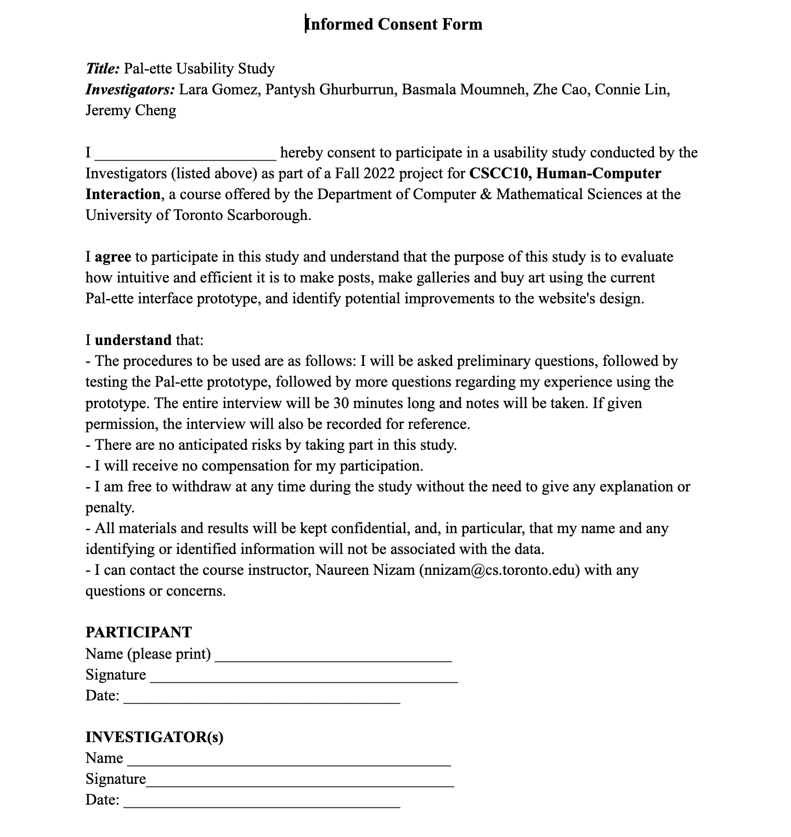

Usability Evaluation Interview Questions

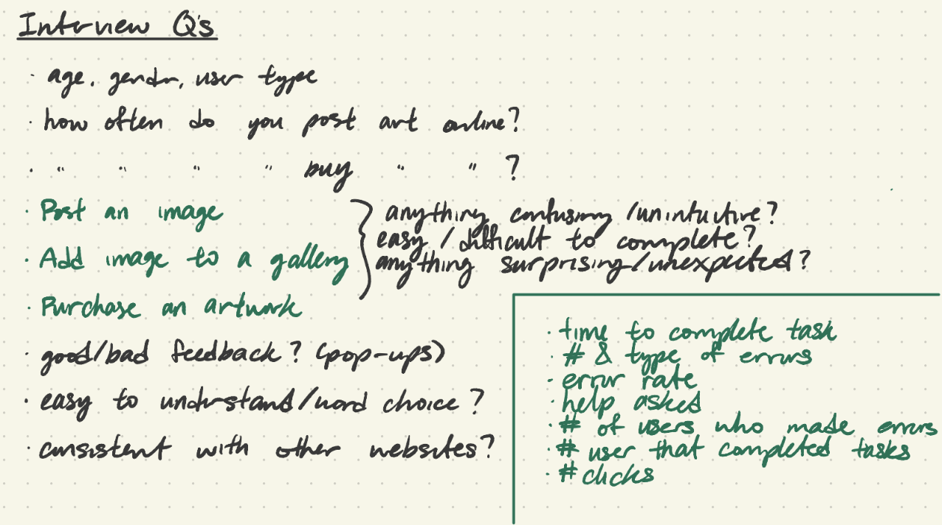

Interview notes